

|  |
| --- |
| Home Mortgage Disclosure Act Data (HMDA)  NewJersey-2017    Project Report |
|  |
| By: Sakshi Jaiswal  DS-540 Project |

# ****Introduction****

The Home Mortgage Disclosure Act (HMDA) requires many financial institutions to maintain, report, and publicly disclose information about mortgages. This dataset covers all mortgage decisions made in 2017 for the state New Jersey. Dataset I found from <https://www.consumerfinance.gov/data-research/hmda/>.

In this dataset we are basically focusing on Home Loan and here in this dataset lots of financial company who is providing loan.

Problem Statement

HMDA was used to generate the following trends which could help Change Financial to calculate and analyse its risks of entering into the “Home Loans” market.

To Analyze Action taken on loan origination, Loan Agency associated with Loan originated, Loan Origination using ethnicity, Loan Approval based on county, Loan Origination Gender wise.

EDA Based on our Dataset

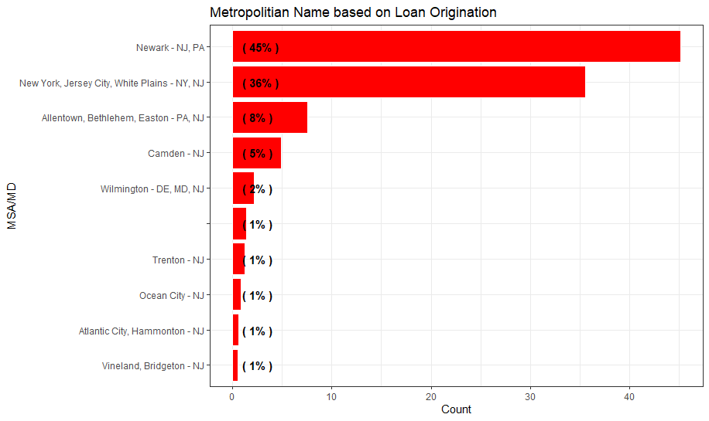

From the insights created using data provided by HMDA, the financial institutions experienced a loan originations from **Newark and Jersey City where loan origination % is more than other Metropolitian** . Nearly 50% of the loans are loan originated . **Home Purchase and Refinancing are the major Loan Purpose types .**

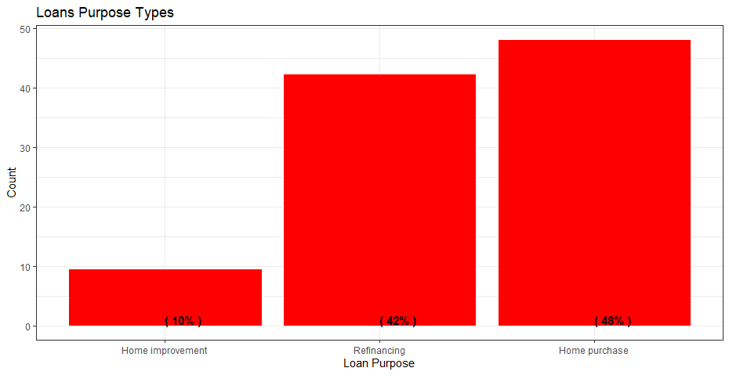

We explore the various races which have been associated with the loan origination process. The White community applies for the largest percentage of loans.

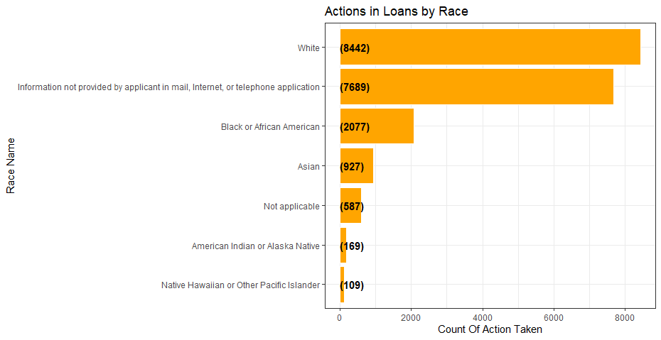Conclusion

Loan Origination Based on combination of following factors:

* Lien Status is the most important feature since it is the first feature used to take the decision.
* Purchase Status is the Second feature used for modelling
* Loan Purchase, Loan Type, County and Loan Amount MSA/MD+ Ethnicity, Applicant ethnicity, Applicant Rac